Title: How to import files using file upload field in GravityImport
Overview: This document covers file import through GravityImport’s file upload field, including troubleshooting common errors and frequently asked questions.
- Troubleshooting common import errors
- Frequently asked questions

Detailed Information
- Go to GravityImport website and login.
- On the Forms tab, click on Import Entries.
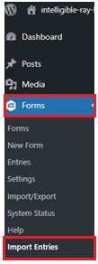
- On the Upload CSV field, drag your file or click to upload.
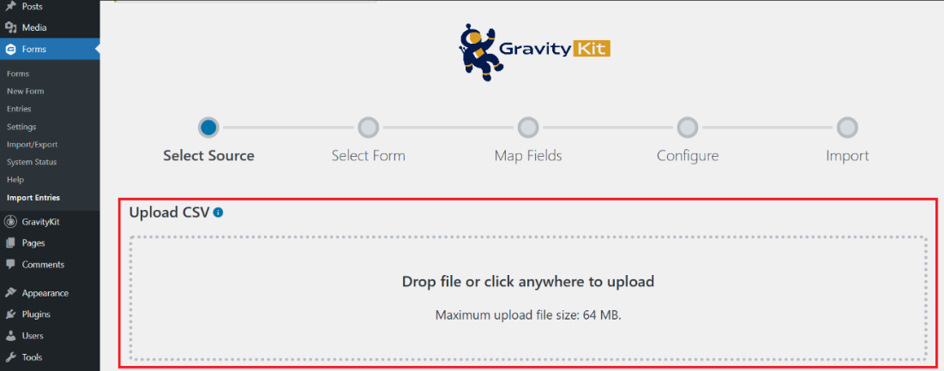
- On the “Where would you like to import the entries” question, select Create a New Form.
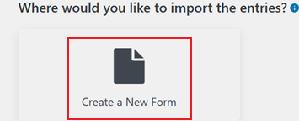
- On the “Add a new form” field, type the name of the form, then click Continue With Import.
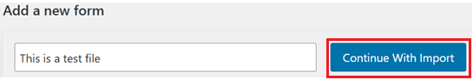
- Map the column of your CSV file to the fields of the GravityImport forms.
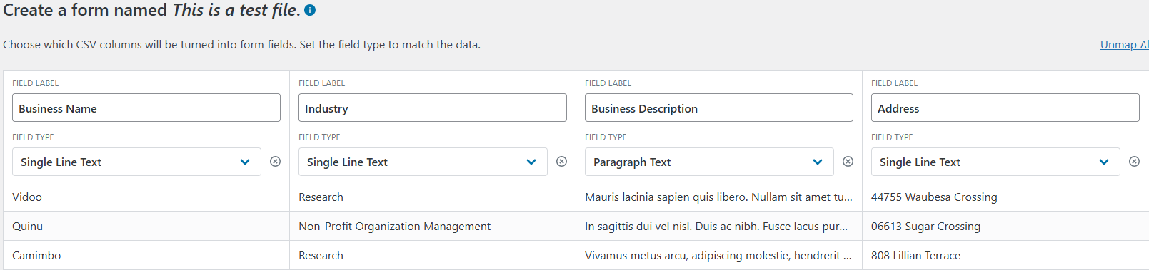
Notes:
  - Choose which CSV columns will be turned into form fields. Set the field type to match the data.
  - The importer automatically detects the different field types of your CSV field.
- Once done click Continue With Import.

- On the Configure Import Options section, enable the button for your preferred configuration options.
  - Continue Processing If Errors Occur – This is enabled by default. Import will not interrupt when errors are encountered.
  - Conditional Import - Only import rows if they match certain conditions.
  - Email Notification - Receive email notification for each imported record
- Click Create Form and Continue With Import.

- Once done an “Import has finished” screen will show to indicate that the import has been completed successfully.
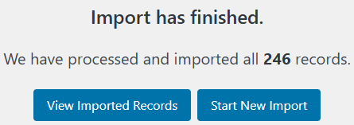

  - If an error occurs, click view log to check the error message. You may refer to the Troubleshooting common errors section on this article.
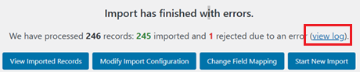

Troubleshooting common import errors
The GravityImport Help section contains basic troubleshooting documents for common errors. You can also open a support ticket for additional assistance.
- Validation Errors (Row Failed Validation)
  - Ensure each CSV value matches the field type
  - Remove extra spaces, hidden characters, or line breaks
  - Use correct formats (e.g., MM/DD/YYYY for dates)
- Column Mismatch (“X columns found, expected Y”)
  - Quote fields with commas
  - Ensure every row has the same number of columns as the header
  - Remove blank lines
- Field Mapping Errors
  - Verify CSV header matches intended field mapping
  - Map each CSV column carefully while importing
  - Remove extra or empty columns
- File Upload Failures
  - Use publicly accessible URLs
  - Format multiple files correctly (comma separated if allowed)
  - Enable “Upload Files” during mapping
- Encoding or Format Issues
  - Save CSV as UTF-8 (Comma-delimited)
  - Ensure standard commas separate fields
  - Clean hidden characters

- Duplicate Entry or Unique Field Conflicts
  - Remove duplicates in CSV
  - Temporarily disable “No Duplicates” on the field
- Large File or Server Issues
  - Split CSV into smaller files
  - Increase PHP upload limit and max execution time
  - Temporarily disable security plugins for import
- Conditional or Missing Field Failures
  - Provide values for all required conditional fields
  - Adjust form logic if needed

Frequently asked questions
Question: How does field mapping relates to file import?
Answer: Field mapping is the bridge between your CSV file and your Gravity Forms fields. It determines what data goes into what field during an import. If mapping is wrong, the import will fail, or your data will be misplaced.

Question: What is the structure required for CSV files when importing individual files?
Answer: Below is the required CSV structure for Gravity Import.
Requirement | Reason
Header row | Required for field mapping
One row per entry | Ensures each entry imports cleanly
Same number of columns | Prevents row alignment errors
Quoted special characters | Prevents broken rows
No blank lines | Avoids "empty row" errors
Standard comma | GravityImport expects CSV (comma)
Empty cells allowed | Keeps structure consistent

Question: I’m unsure whether file importing works with new or existing forms.
Answer: Yes, file importing works with both new and existing forms.

Question: What is the purpose and functionality of the “Upload Files” option within field mapping?
Answer: The “Upload Files” option allows GravityImport to handle File Upload fields in your form by linking CSV provided file URLs or paths to the form entries.

